Visualization Library Documentation

Objective
This document provides an overview of popular Python visualization libraries and demonstrates different types of graphs that can be created using them. The guide is intended for beginners to understand visualization techniques and their practical applications.
1. Matplotlib
Description
Matplotlib is a widely used Python visualization library that allows users to create static, animated, and interactive plots. It provides full control over visual elements such as labels, colours, and styles, making it suitable for detailed and customized visualizations.
Use Case:
Used in data analysis, scientific research, and academic projects.
A plot of matplotlib contains:
1 Figure
2 Axes
3 Axis
4 Artists
- Figure
Figure is the container in which plots are present. It can have a single plot or multiple plots.
- Axes
Axes are the plots, and they are artist attached to the figure. A plot can have 2 or 3 axes. set_xlabel(), set_ylabel() are the functions used to set the labels of x and y respectively.
- Axis
It is responsible for generating ticks or the limits on the axes.
- Artists
The whatever content visible in a figure are the artists.

1.1 Line Plot
Description:
A line plot is used to display trends and changes over continuous data.
Use Case:
Commonly used to show changes over time, such as sales growth or temperature variation.
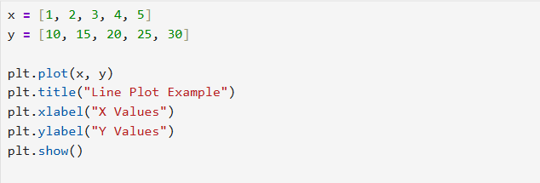

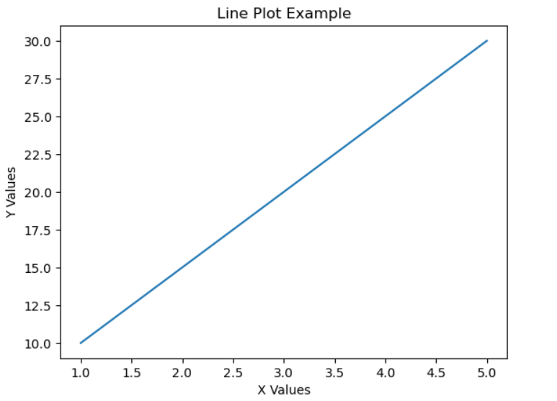
DESCRIPTION
- plt.plot(x, y)
Draws a line graph by connecting data points from x and y.
- plt.title("Line Plot Example")
Adds a title to the graph for better understanding.
- plt.xlabel("X Values")
Labels the horizontal (X) axis.
- plt.ylabel("Y Values")
Labels the vertical (Y) axis.
- plt.show()
Displays the final graph on the screen.

1.2 Scatter Plot
Description:
A scatter plot shows the relationship between two numerical variables using individual data points.
Use Case:
Used to identify correlations or patterns in datasets.
CODE SNIPPET
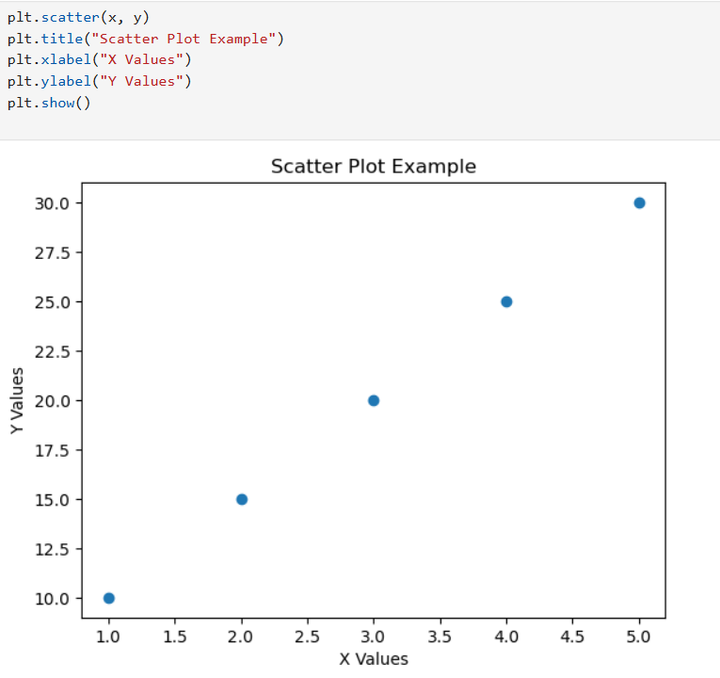

DESCRIPTION :
- plt.scatter(x, y)
Creates a scatter plot where each point represents a data pair from x and y.
- plt.title("Scatter Plot Example")
Sets the title of the scatter plot.
- plt.xlabel("X Values")
Names the values shown on the X-axis.
- plt.ylabel("Y Values")
Names the values shown on the Y-axis.
- plt.show()
Renders and displays the plot.

1.3 Bar Chart
Description:
A bar chart represents categorical data using rectangular bars.
Use Case:
Used to compare values across different categories.
CODE SNIPPET
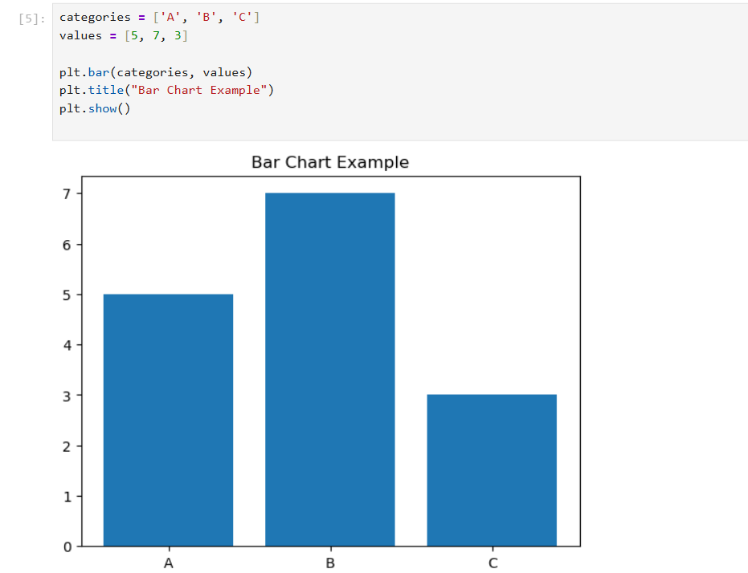
DESCRIPTION :
- plt.bar(categories, values)
Creates a bar chart where each category is represented by a bar with a corresponding value.
- plt.title("Bar Chart Example")
Adds a title to describe the chart.
- plt.show()
Displays the bar chart.
2. Seaborn
Description
Seaborn is a statistical data visualization library built on top of Matplotlib. It provides a high-level interface for drawing attractive and informative statistical graphics with minimal code.
Use Case:
Used for statistical analysis and exploratory data visualization.
2.1 Histogram
Description:
A histogram shows the frequency distribution of a dataset. A histogram with KDE (Kernel Density Estimation) shows both data distribution and density.
Use Case:
Used to analyze data distribution and frequency patterns. Used to understand data spread and probability density.

CODE SNIPPET:
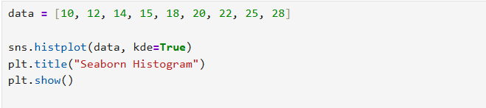

DESCRIPTION
- sns.histplot(data)
Creates a histogram using Seaborn with enhanced styling.
- kde=True
Adds a smooth density curve (Kernel Density Estimation).
- plt.title("Seaborn Histogram")
Adds a title to the plot.
- plt.show()
Displays the histogram.
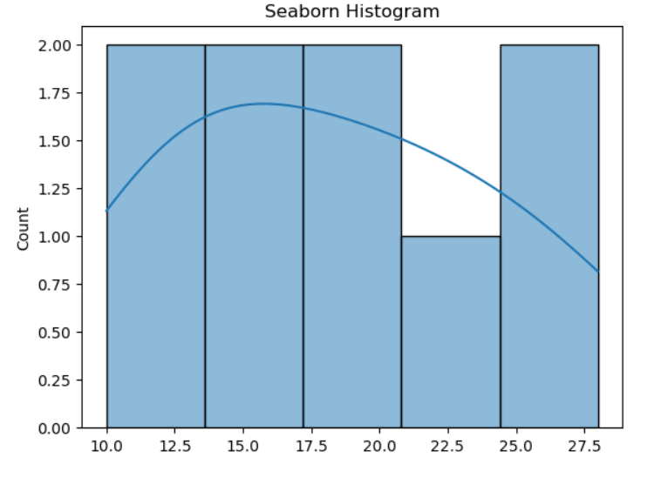

2.2 Box Plot
Description:
A box plot displays data distribution, median, quartiles, and outliers.
Use Case:
Used to detect outliers and compare distributions.
CODE SNIPPET :
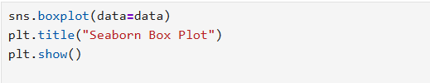
DESCRIPTION
- sns.boxplot(data=data)
Creates a box plot showing median, quartiles, and outliers.
- plt.title("Seaborn Box Plot")
Adds a title to the plot.
- plt.show()
Displays the box plot.
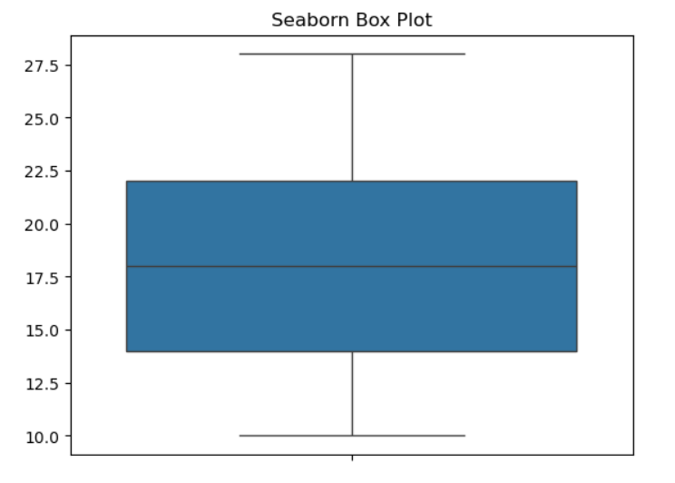
COMPARISON OF MATPLOTLIB AND SEABORN
Matplotlib:
- Core Library: Matplotlib is a comprehensive library for creating static, animated, and interactive visualizations in Python. It provides a low-level interface for creating plots with fine-grained control over every aspect of the figure.
- Flexibility: Matplotlib allows users to create any type of plot imaginable, from basic line plots and scatter plots to complex 3D plots and geographical maps.
- Mature: Matplotlib has been around for a long time and is a well-established library in the Python ecosystem. Many other libraries, including Seaborn, are built on top of Matplotlib.
- Customization: Matplotlib offers extensive customization options, allowing users to customize every aspect of a plot, including colors, line styles, markers, fonts, annotations, and more.
- Integration: Matplotlib can be easily integrated with other libraries and frameworks, such as NumPy, Pandas, SciPy, which makes it a versatile choice for data visualization in various contexts.
Advantages of Matplotlib:
- High degree of customization and control over plots.
- Wide range of plot types and styles.
- Strong community support and extensive documentation.
- Well-suited for creating publication-quality figures and graphics.
Seaborn:
- High-Level Interface: Seaborn is built on top of Matplotlib and provides a high-level interface for creating attractive and informative statistical graphics. It simplifies the process of creating complex visualizations by providing default aesthetics and convenient functions for common tasks.
- Statistical Plotting: Seaborn specializes in statistical plotting and offers a variety of plot types specifically designed for visualizing relationships in data, such as scatter plots, bar plots, box plots, violin plots, pair plots, and more.
- Aesthetics: Seaborn comes with built-in themes and color palettes that make it easy to create visually appealing plots with minimal effort. It also provides tools for fine-tuning plot aesthetics, such as controlling the size of plot elements and adjusting the color palette.
- Integration with Pandas: Seaborn seamlessly integrates with Pandas dataframes, allowing users to easily plot data stored in Pandas data structures without the need for extensive data manipulation.
Advantages of Seaborn:
- Simplified syntax and high-level functions for creating complex plots.
- Built-in support for statistical plotting and data exploration.
- Attractive default aesthetics and color palettes.
- Seamless integration with Pandas dataframes for data visualization.
- Ideal for exploratory data analysis and quick visualization of relationships in data.
Overall, the choice between Matplotlib and Seaborn depends on the specific requirements of data visualization task. Matplotlib is preferred for its flexibility and fine-grained control over plots, while Seaborn is preferred for its ease of use, statistical plotting capabilities, and attractive default aesthetics. Many users combine both libraries, leveraging the strengths of each as needed.
Conclusion
Matplotlib and Seaborn are powerful Python visualization libraries. Matplotlib provides extensive customization options, while Seaborn simplifies statistical visualization with better aesthetics. Together, they offer a complete visualization solution for data analysis.

